Copyright © 2020 by Ingenium

Ingenium 2019-2020 Pre/Post Test: Evaluation
By Junghee Han, PhD, MSW, Evaluation Consultant
Ingenium’s Strong Character Program aims to develop strong character skills in students by increasing three areas of strong character—positive mindset, healthy emotions, and successful behaviors. At the beginning of the program, participants take a pre-test measuring their positive mindset, healthy emotions, and successful behaviors. After working through the Strong Character Program, participants take a post-test to measure their improvement after going through the program.
The purpose of this evaluation is to determine if participants who have gone through the Strong Character Program are improving in their positive mindset, healthy emotions, and successful behaviors.
Description of Sample
In the Ingenium 2019–2020 Pre/Post Test dataset, there were a total of 361 responses (N=361). A majority of the cases in this sample were African American at 63.3%, followed by Multiracial with 22.7%, and Hispanic/Latino at 10.2%. The smallest number of cases in this dataset were White with 3.2% and Asian/Pacific Islander with 0.6%. Of the participants included in the sample, 193 (56.6%) were male and 148 (43.4%) were female. Participant age spanned 10 different ages with the age of 9 being the minimum and the age of 19 being the maximum. The mode age of the respondents was 13 with a frequency of 54 cases. The mean age of the respondents was 13.44 (SD=2.367). Participant grade spanned 8 grade levels with 4th grade being the minimum grade level and 12th grade being the maximum grade level. The mode grade level is 6th grade with a frequency of 57 cases. The mean grade level of the respondents was 8.07 (SD=2.224). Participant ZIP code spanned a total of 21 different codes. A total of 173 cases, or half of the total valid cases (51.6%), were from the 49507 ZIP code. The next highest ZIP codes were 49508 with 9.9% of the total valid cases, 49506 with 9.6%, and 49503 with 8.4% of cases.
Strong Character Program Pre/Post Test Results: Improvement
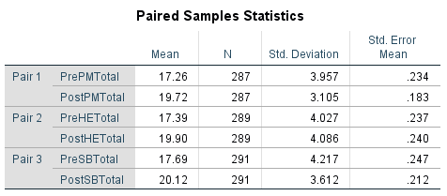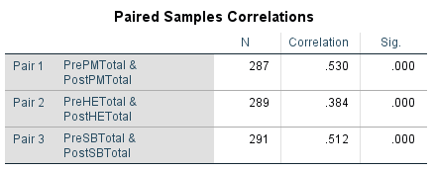
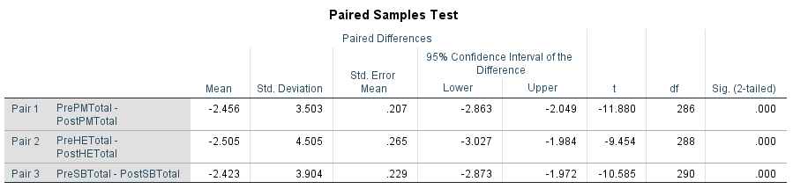
A paired samples t-test was performed to measure if there is a change before and after receiving an intervention (Strong Character). First, means from pre-tests and post-tests were compared for positive mindset, healthy emotions, and successful behaviors.
The results showed that there was an improvement from pre-test results to post-test results in positive mindset, healthy emotions, and successful behaviors. The average post-test positive mindset score was 19.72 (SD=3.105), which was 2.46 points higher than pre-test positive mindset scores. This is statistically significant (p < 0.05). The average post-test healthy emotions score was 19.90 (SD=4.086), which was 2.51 points higher than pre-test healthy emotions scores. This is statistically significant (p < 0.05). The average post-test successful behaviors score was 20.12 (SD=3.612), which was 2.43 points higher than pre-test successful behaviors scores. This is statistically significant (p < 0.05). Thus, the results conclude that the Strong Character Program is effective in increasing participants’ positive mindset, healthy emotions, and successful behaviors scores.

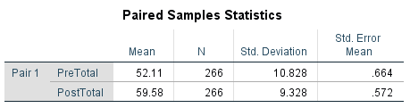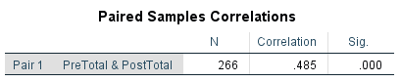
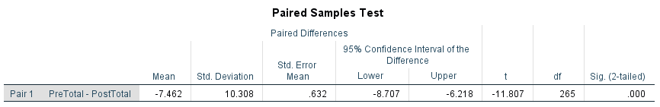
Additionally, a paired samples t-test was conducted to measure the relationship between pre-test and post-test results comparing the means of total tests scores (positive mindset, healthy emotions, and successful behaviors scored together).
The results showed that there was an improvement from pre-test total results to post-test total results. On average, post-test total score was 59.58 (SD=9.328), which is 7.47 points higher than the pre-test total score. This is statistically significant (p < 0.05). Thus, these results conclude that the Strong Character Program is effective in increasing participants’ total strong character scores. A potential type I error could be made through this paired samples t-test.

Pre/Post Test Total Scores: Race
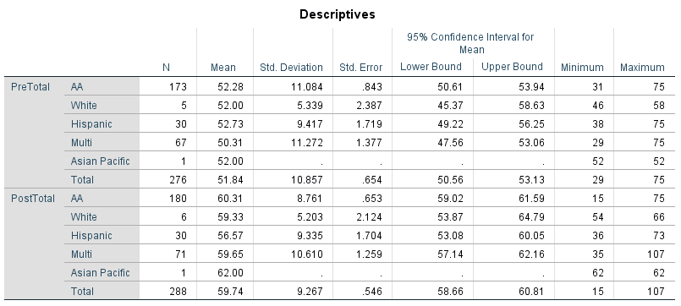
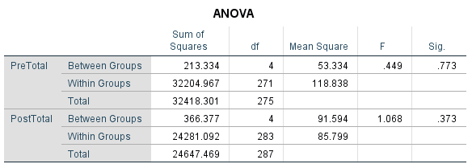
A one-way ANOVA test was performed between pre- and post-test results and race to see if there was any correlation between race and test scores. The results showed that there is no significant relationship between pre-test and post-test total scores and race/ethnicity. This means that race/ethnicity is not a potential confounding variable in the relationship between the intervention (Strong Character Program) and test scores.

Pre/Post Test Total Scores: Gender
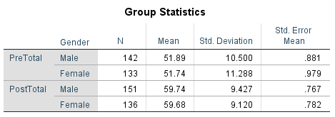
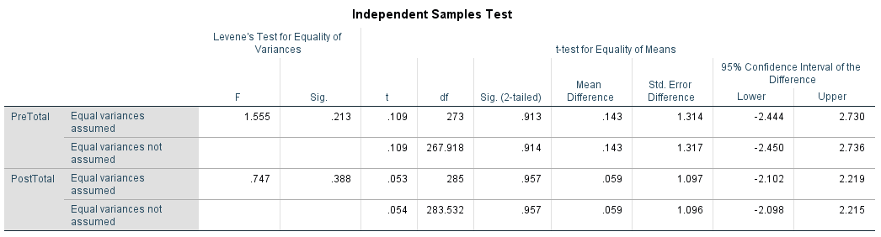
An independent samples t-test was performed between pre- and post-test results and gender to see if there was any correlation between gender and test scores. The results showed that there is no relationship between gender and test scores. The average post-test score for males (N=151) is 59.74 (SD=9.427), which is 7.85 points higher than the average pre-test score for males. The average post-test score for females (N=136) is 59.68 (SD=9.120), which is 7.94 points higher than the average pre-test score for females. These results were not statistically significant (p = 0.388; 0.213).
Again, gender is not a potential confounding variable which should be controlled for in multivariate analyses.

Pre/Post Test Total Scores: Age
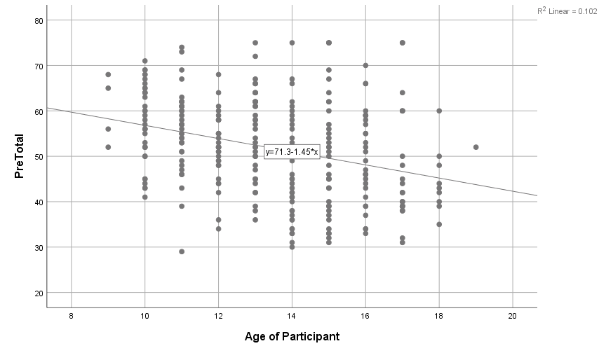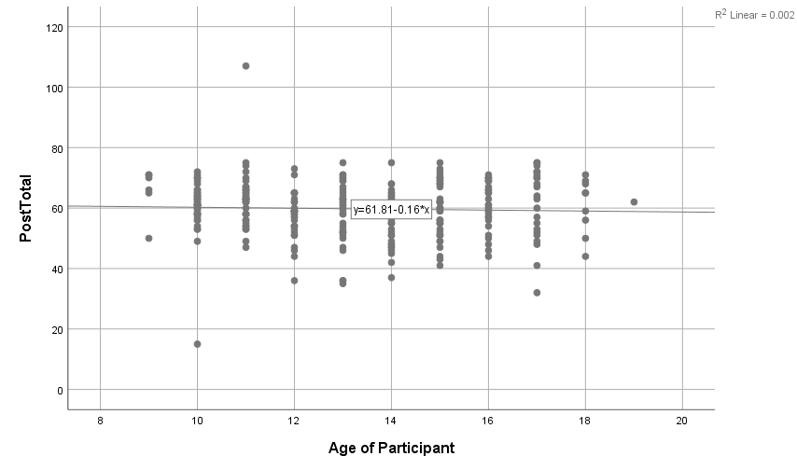
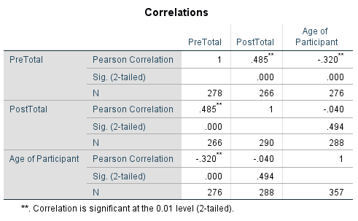
A Pearson’s correlation test was performed between pre- and post-test results and participant age to determine if there is any correlation between participant age and test scores. The results showed that there is a moderate negative correlation (r = -0.320) between age and pre-test scores (p = 0.00). The results also showed that there is no relationship between post-test scores and age (p = 0.494).
Thus, the variable of age should be controlled for in the multivariate analyses.
Pre/Post Test Total Scores: Grade 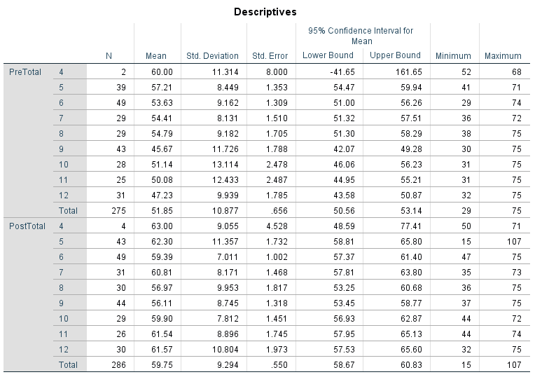
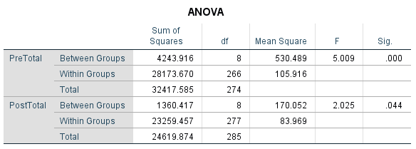
A one-way ANOVA test was performed between the pre- and post-test results and participant grade level to determine if there was any relationship between participant grade level and test scores. There is an association between participant’s grade level and both pre- and post-test scores (p = 0.00; 0.044).
Thus, a study participant’s grade should be controlled for in multivariate analyses.

Pre/Post Test Total Scores: ZIP code
There was no relationship between participant ZIP code and pre-test scores and post-test scores.

